01/19/2023 Call + Notes:

January | Solve battery crisis so we can get Glorb off trailer (Phase 1)  - Pick jan/feb date to troubleshoot battery issue  Begin DMV design renderings  Begin DMV application start
February | DMV App opens feb 15
March | 2nd week of March - Boise build week!  - Install suspension  - Fix Brakes  Glorb moves into its home  Batteries Phase 2
April | DMV application due April 12
May | Build
June | Build
July | Build
August | Finish/cum together

Glorb Tasks
Immediate Tasks
- Warehouse space
- Suspension Upgrade
  - Can do suspension but not battery but need battery to be solved first to reduce cost
  - ~1 week for airbag suspension upgrade
  - Determine how many people it needs to hold
  - Weight limit will change

- Battery
  - Concern: weak point, required on playa work, need root cause playa issues
  - Goals:
    - Brain dump
    - Make batteries happy 🙂
    - Aux power to allow max thumps
    - Removable batteries?
  - Battery Phase 1 - make it move
  - Battery Phase 2 - min upgrades
  - Battery Phase 3 - wanted upgrades
- Solar transition
  - Maybe a panel for cellphones everything else bonus
- Design
  - Easily-poopable design
  - Triangle
  - What does Glorb Mean to you?
    - Friendship, Adaptable/Flexible, adventure, no pooping
  - Mounted to chassis this year
  - Considerations
    - Wind
    - Rain
    - Lightning
  - Mermeow mobile pussy palace
  - 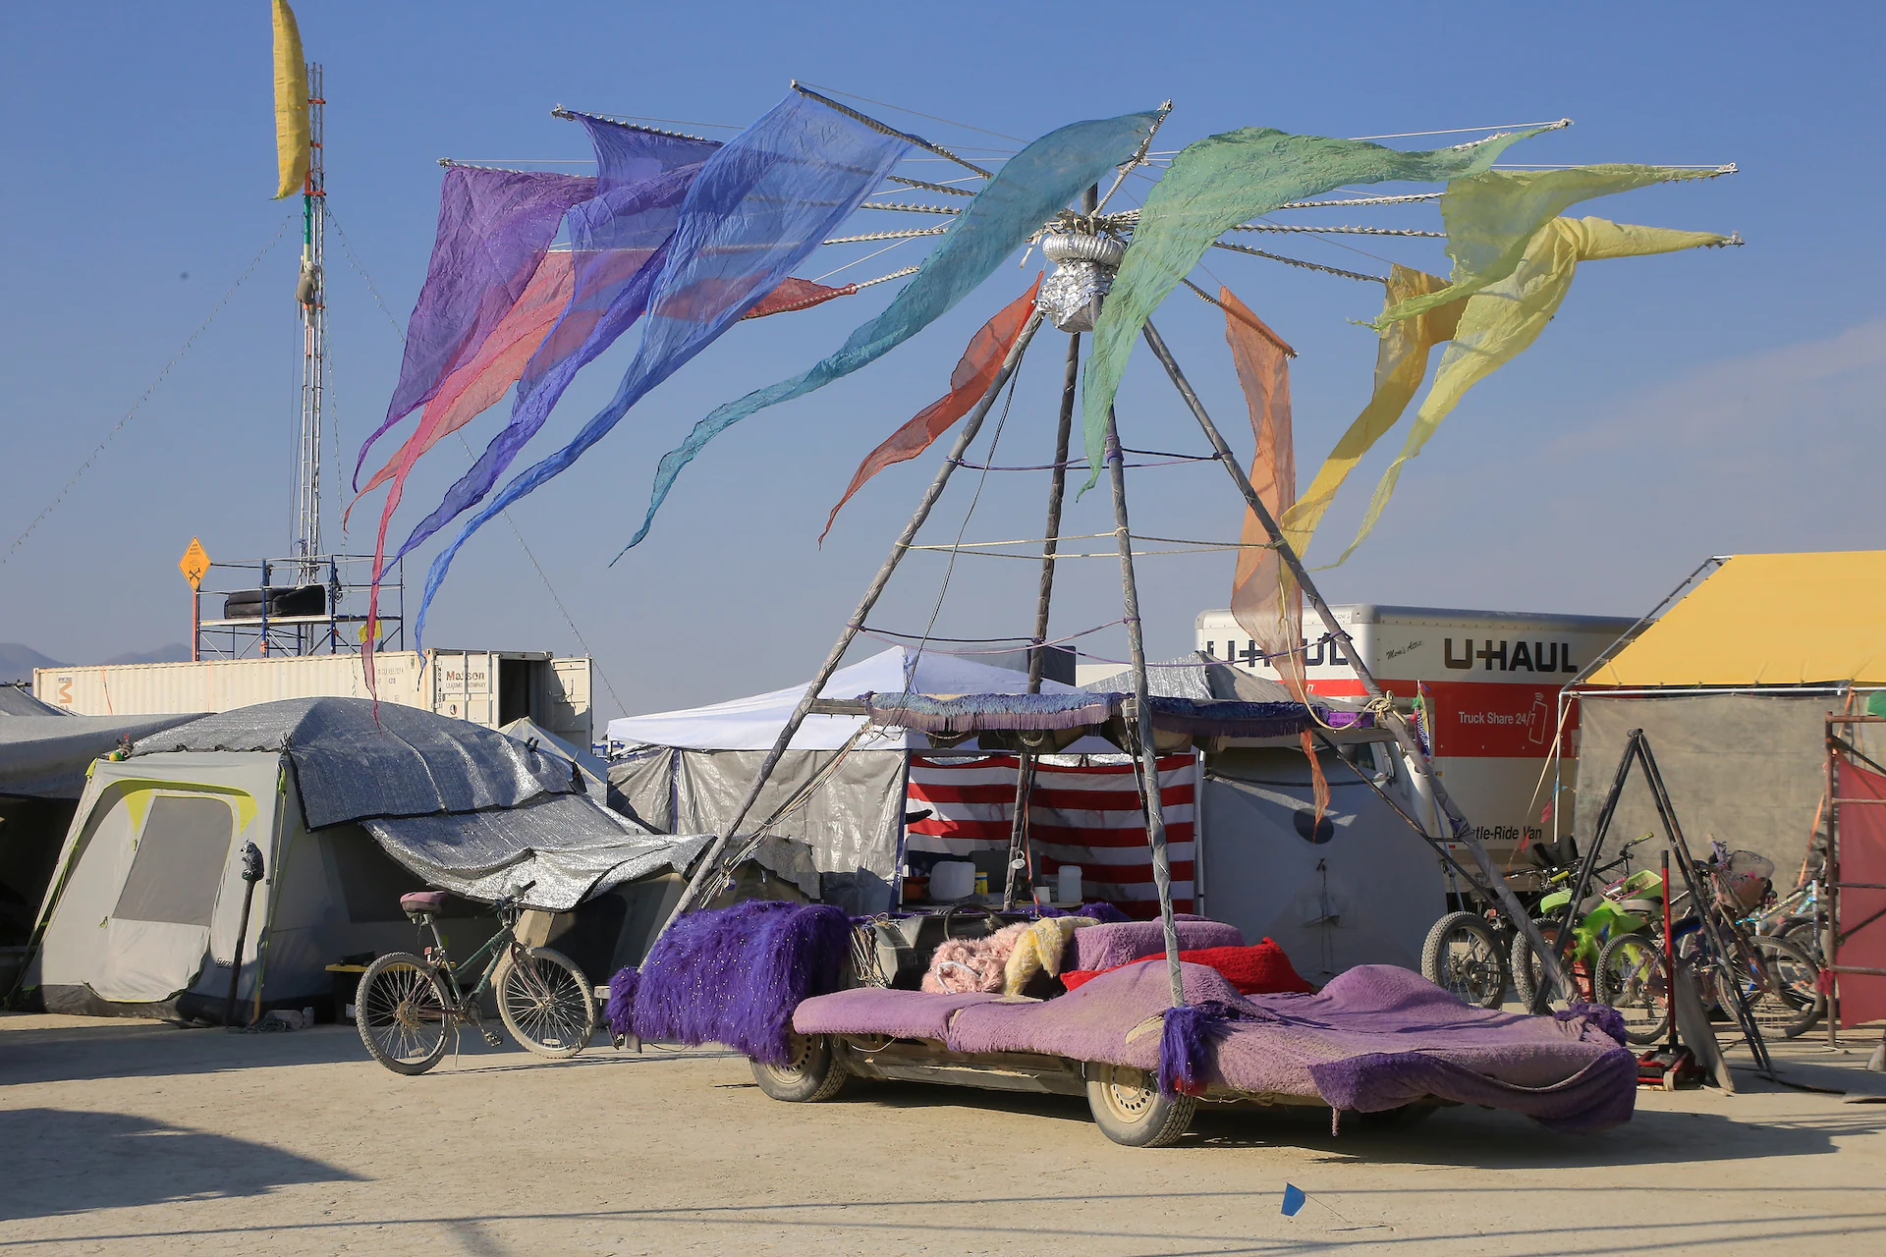
  - 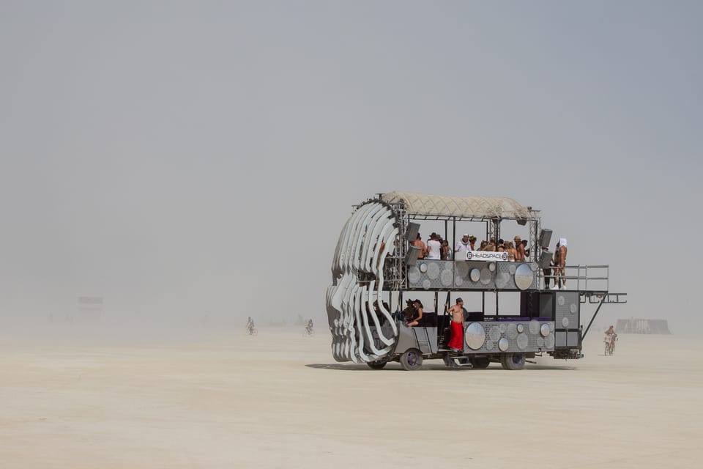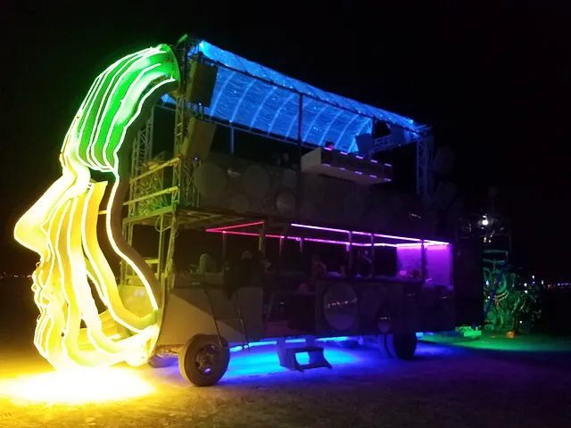
  - 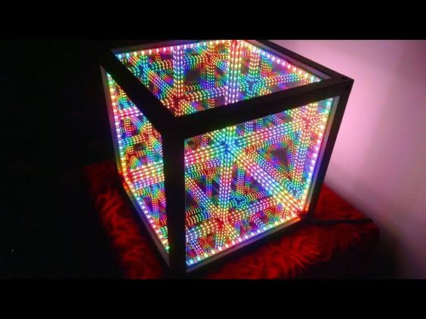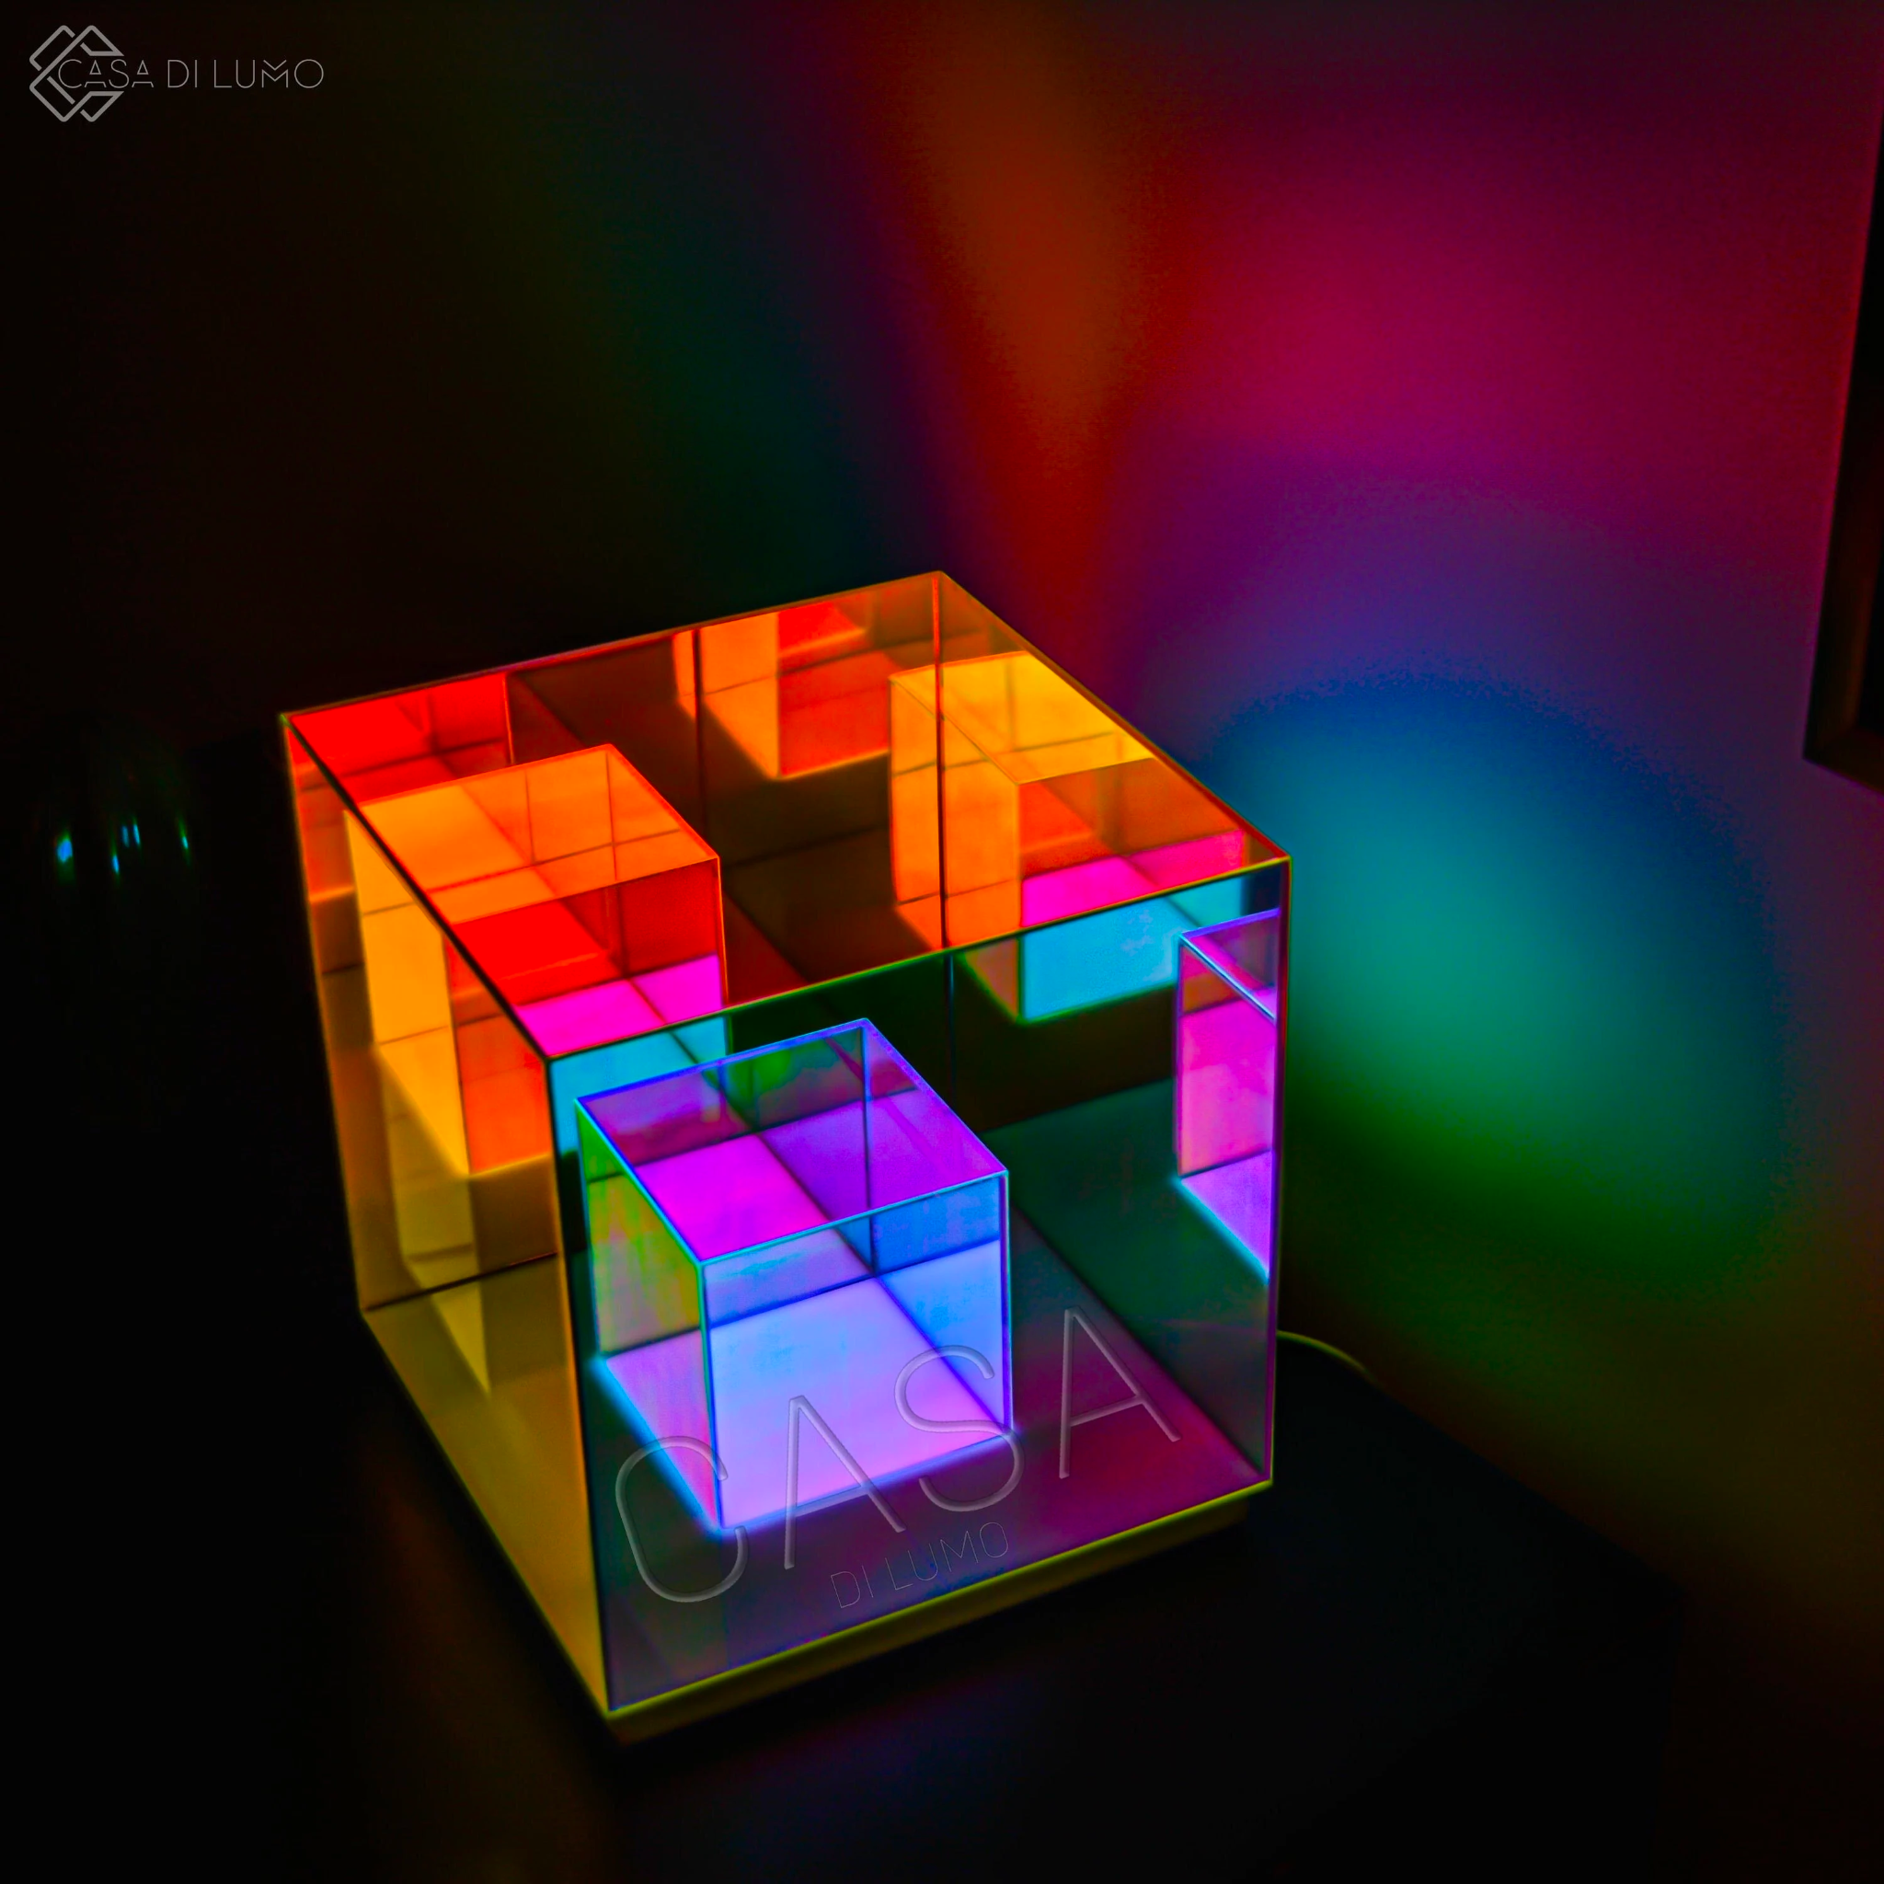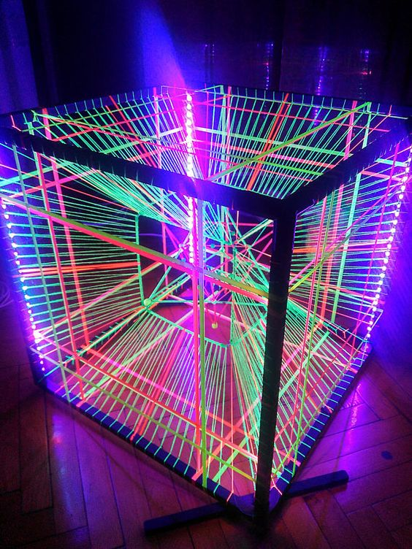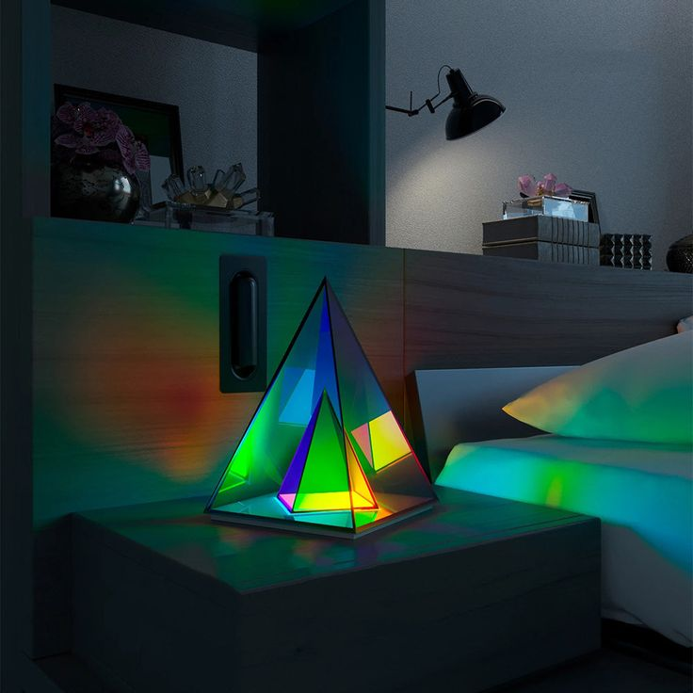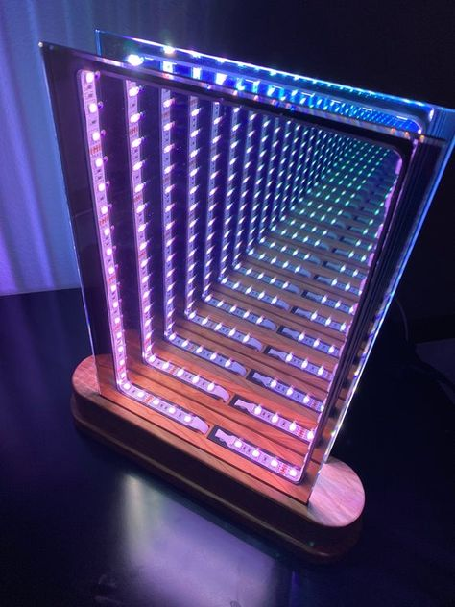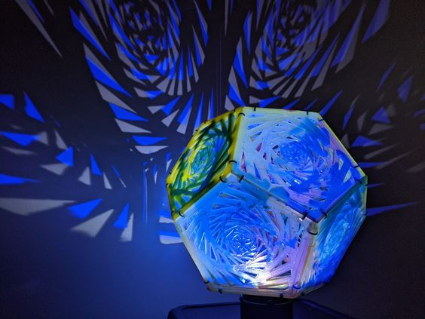
  - What we liked about 2022
    - We like it open and viewing to the sides
    - Bottom floor made it easy to transport
  - Lessons learned
    - On playa build was too much
    - Straps led to folks grabbing them and loosening the duxel
  - Ideas
    - Permanent shape vs build and take down on playa
    - Rectangle, walls on hinges to open and close
    - Solar panel on the car ^ walls could be solar panels
    - Can we test this out before the playa? Group camping trip?
    - Illusion
      - Fabrics?
      - Need infiniti mirror but maybe part of the car is as a prototype vs the entire car
    - Having a floor could protect the batteries
    - Look at roof pedestal systems or social construct construction
    - Need to be able to easily access the batteries
    - Back wall is the mirror or series of cubes
    - ONE BIG HAND
  - Needs
    - Batteries in the floor, we hang out on the floors, need to easily access the batteries for trouble shooting, need a cover for the floor to protect them from liquids, etc.
  - Constraints
    - 1000 lbs trailer cap
      - 9 batteries about 100 lbs each, removable?
    - Wheels have to be covered
    - WOWwwww factor for day and night time
      - Day - Greek palace white curtain and gold
      - Night - LED
  - To dos
    - Need Link to glorb cut sheet
    - Liana will do the rendering
    - Chris to send me dims
    - Marko to help with attachment
    - Mike to help with base too
    - Make a sign, DO NOT POOP ON THIS CAR OR ELSE
    - Marko, Henri, Liana to design the car

- Assign Team leads
  - Leadership
  - Mechanics
  - Decor/Design
  - Lighting
  - Power
  - Sound
- New Design sketches

Mid-term tasks
- Solar transition
- Design/Decor
- CNC more Duxels?

TEAMS
- Leadership (Chris/Mike/Jessi/Hunter)
  - Jobs
    - Organization
      - Project management
      - Build weekends, etc.
    - Storage
    - Transport (Hunter)
    - Infrastructure (Hunter)
    - Maintenance
- Mechanics (Chris/Mike)
  - Jobs
    - Suspension
    - Body work
- Decor/Design (Cara/Liana/Jessi/Brooke/Hunter)
  - Jobs
    - Glorb redesign (ship to mechanics team)
    - Acquire materials
  - Design doc: https://docs.google.com/document/d/1HsRZCY1Q8RgPQKqHTnDoPIt3EDETT75Lsh9fcuOAsoA/edit
- Lighting (Chris/Liana)
  - Jobs
    - Coordinate with Decor team
    - Acquire materials
    - Design controller/electronics layout
    - Wire and build
- Power (Chris/Mike)
  - Jobs
    - Source bigger, more reliable batteries
    - Utilize existing battery packs for auxiliary systems
    - Solar transitions
- Sound (Cara)
  - Jobs
    - Design sound system
    - Design placement
    - Build

